Zhou Yuanyu

222040002

**Testing and application of the victory factor model**

Assignment 1

**ABSTRACT**

The purpose of this report is to provide fund selection for active equity funds. We selected the "victory" factor as the gene selection and backtested the data from 2016 to 2022, and provided the latest fund selection results. According to Shenwan's primary industry classification, active equity funds are divided into 31 secondary fund pools, and the "victory" factor is discussed in the industry.

**Key words：factor model, "victory" factor, the whole market level, industry level**

**Contents**

ABSTRACT 1

1. The whole market level 3

1.1. Model parameters of the "Victory" factor FOF strategy 3

1.2. The fund optimizes the construction of the "victory" factor 3

1.2. Backtesting results: The fund's "winning" preferred strategy 4

1.2.1 When t=12 4

2. Industry level 9

2.1. Inspiration——Are industry classifications still valid? 9

2.2. Industry fund pool construction 9

2.3. Model parameters of the "victory" factor FOF strategy 10

2.4. Backtesting results: "victory" preferred strategies for industry-level funds 10

2.4.1 Food and beverage 10

2.4.2 Electrical equipment 10

2.4.3 Pharmaceutical Biotechnology 11

References 12

# **The whole market level**

## Model parameters of the "Victory" factor FOF strategy

|  |  |
| --- | --- |
| Parameter | The range of settings |
| Sample range | Common equity funds and partial equity hybrid funds in the whole market active equity-biased public funds, considering that these two stock holdings account for relatively large proportions, which are more in line with the dimension of active management. |
| Backtesting Interval | January 1, 2016 to December 31, 2022 |
| Data frequency | daily |
| Frequency of position adjustment | monthly |
| Filter | Initial fund, non-suspended and non-graded fund, no closed operation period |

## 1.2. The fund optimizes the construction of the "victory" factor

"Victory" is defined as the maximum value of a fund's net value in the current month is greater than the average of the maximum net value of the previous t months. First, find the maximum value of the fund's monthly net value; Secondly, the average of the maximum net worth of the previous t month is calculated on a rolling basis, and the "victory" factor is constructed by using the ratio of the difference between the two to the mean. Finally, the “victory" factors of active equity-biased funds are sorted from smallest to largest, backtested in groups, and the 10 funds with the largest factors are screened to construct a TOP10 portfolio.

Where is the number of the current month, which represents the maximum value of the net value in the i month, and represents the average of the maximum value of the net value of the previous t month. With the evaluation indicators of the fund pool, the "victory" indicator values and ranking of the past months can be retrospectively traced to the fund every month.

The factors were sorted from smallest to largest, and the fund pool was divided into 20 groups on average, and group 1 was the most group of the factor, that is, the group with the lowest degree of "victory" in the month. Group 20 is the group with the largest factor of the factor, that is, the group with the highest degree of "victory" in the month. Then, the FOF portfolio of 20 dynamic funds was backtested historically, and the effectiveness of the factor was judged by the historical results of backtesting. If the net value of the index shows a unilateral decline law from group 20 to group 1, it indicates that the effectiveness of the indicator is strong. If the indicator is valid, a stronger enhanced Top10 portfolio is constructed, that is, the top 10 funds from the fund pool are selected to construct the FOF portfolio, which is compared with the full sample of equal-weighted FOF portfolios.

## Backtesting results: The fund's "winning" preferred strategy

The rolling window values t=12, 24, 36 and 48 were backtested respectively, representing the "victory" of the fund in 1 year, 2 years, 3 years and 4 years, and the effectiveness of the factors was found to be strong, so the FOF combination of each group constructing Top10 was compared with the full-sample equal-weight FOF combination. The groups are as follows:

### When t=12

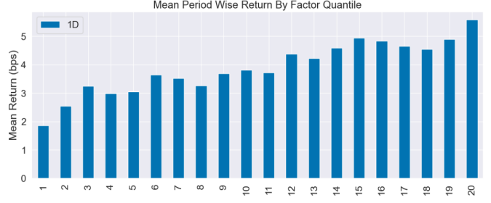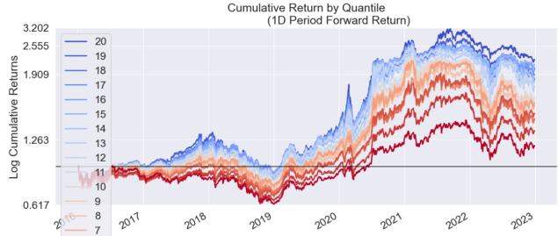

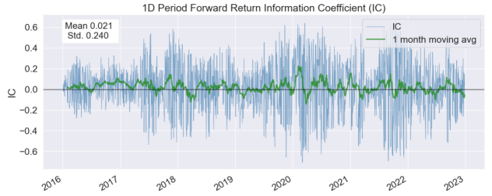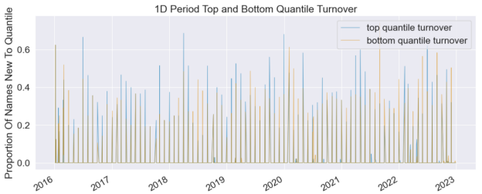 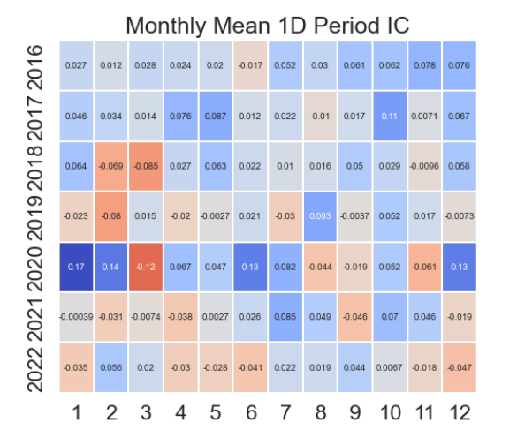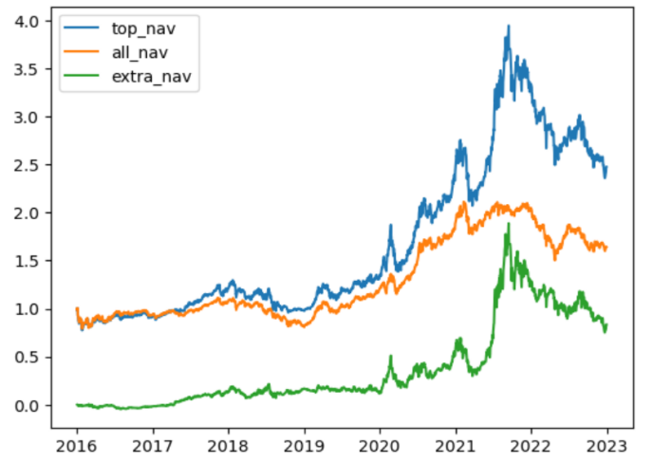

|  |  |
| --- | --- |
| Return/Information Analysis |  |
| Ann.alpha | 0.070 |
| beta | 0.191 |
| Mean Period Wise Return Top Quantile (bps) | 5.582 |
| Mean Period Wise Return Bottom Quantile (bps) | 1.868 |
| Mean Period Wise Spread (bps) | 3.714 |
| IC Mean | 0.021 |
| IC Std. | 0.240 |
| Risk-Adjusted IC | 0.088 |
| t-stat(IC) | 3.639 |
| p-value(IC) | 0.000 |
| IC Skew | -0.209 |
| IC Kurtosis | -0.026 |

* + 1. **When t=24**

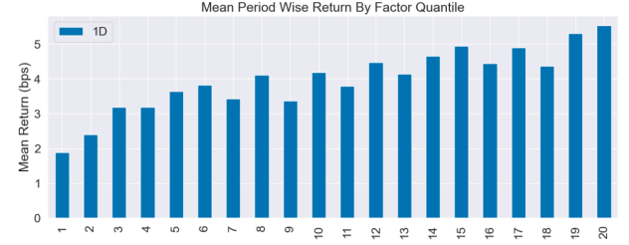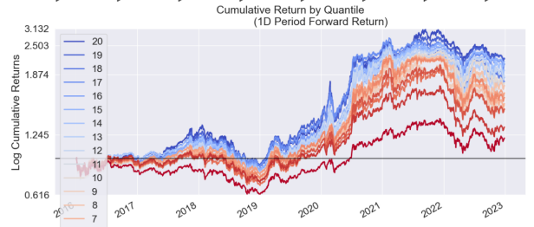

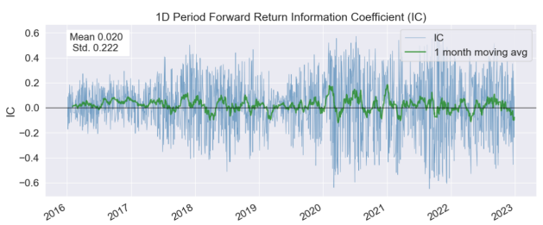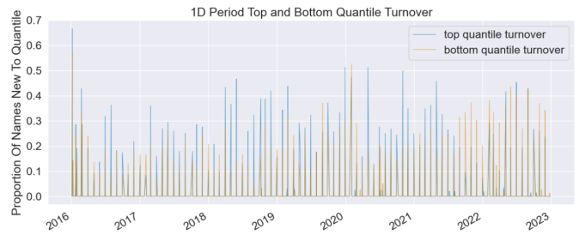

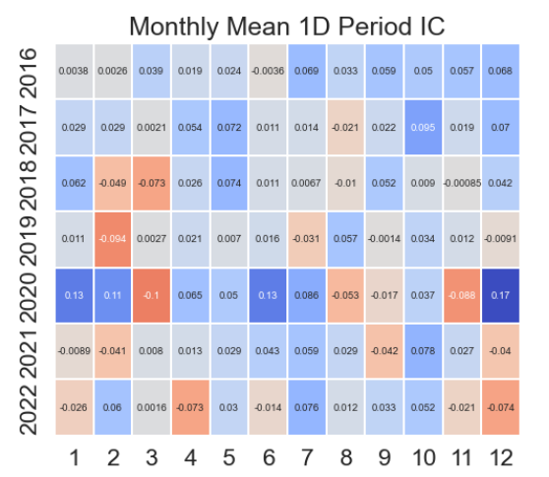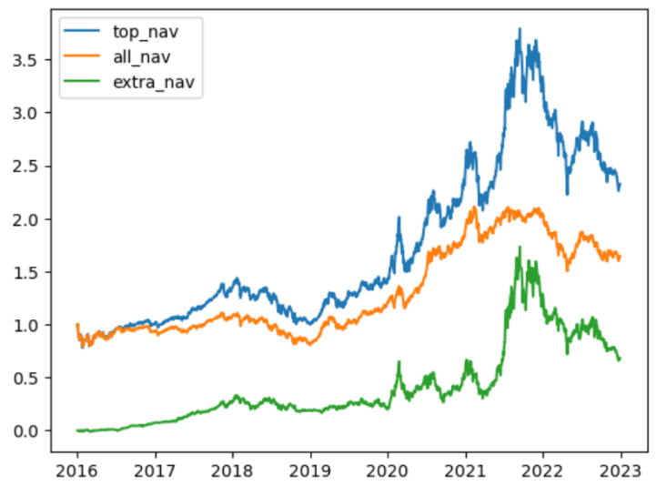

|  |  |
| --- | --- |
| Return/Information Analysis |  |
| Ann.alpha | 0.002 |
| beta | 0.441 |
| Mean Period Wise Return Top Quantile (bps) | 5.529 |
| Mean Period Wise Return Bottom Quantile (bps) | 1.892 |
| Mean Period Wise Spread (bps) | 3.637 |
| IC Mean | 0.020 |
| IC Std. | 0.222 |
| Risk-Adjusted IC | 0.091 |
| t-stat(IC) | 3.737 |
| p-value(IC) | 0.000 |
| IC Skew | -0.199 |
| IC Kurtosis | -0.152 |

* + 1. **When t=36**

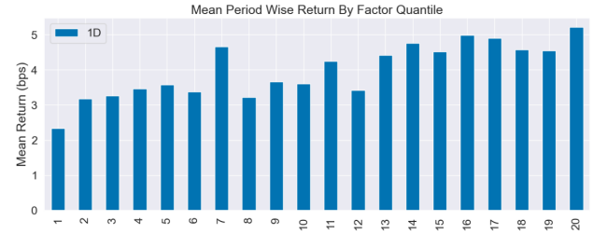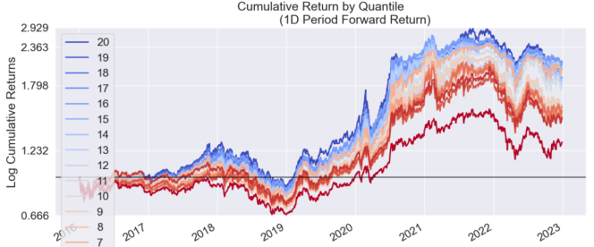

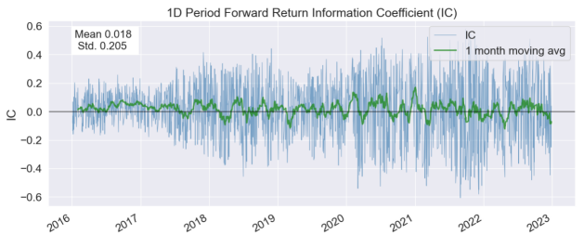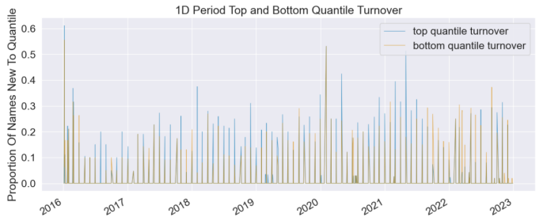

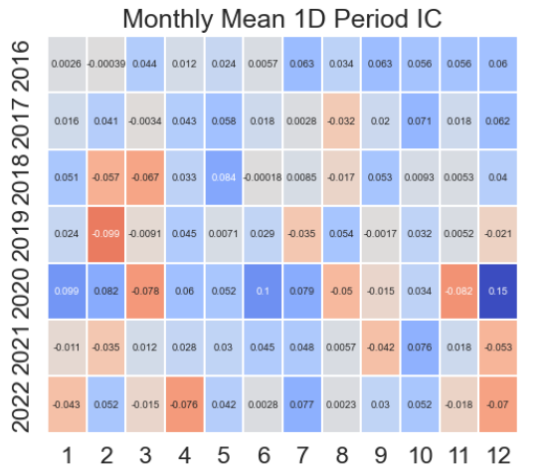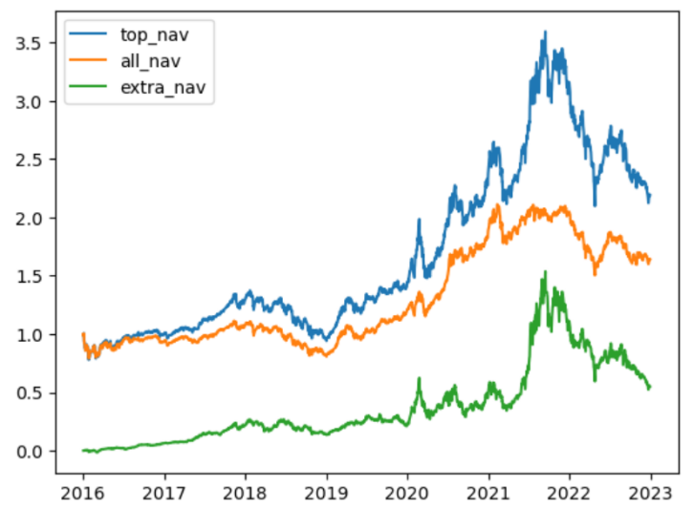

|  |  |
| --- | --- |
| Return/Information Analysis |  |
| Ann.alpha | -0.017 |
| beta | 0.641 |
| Mean Period Wise Return Top Quantile (bps) | 5.213 |
| Mean Period Wise Return Bottom Quantile (bps) | 2.341 |
| Mean Period Wise Spread (bps) | 2.872 |
| IC Mean | 0.018 |
| IC Std. | 0.205 |
| Risk-Adjusted IC | 0.086 |
| t-stat(IC) | 3.546 |
| p-value(IC) | 0.000 |
| IC Skew | -0.199 |
| IC Kurtosis | -0.261 |

* + 1. **When t=48**

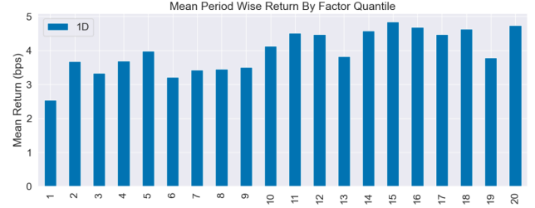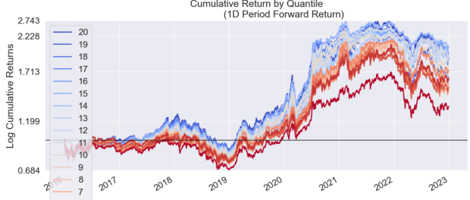

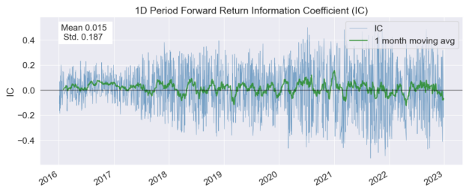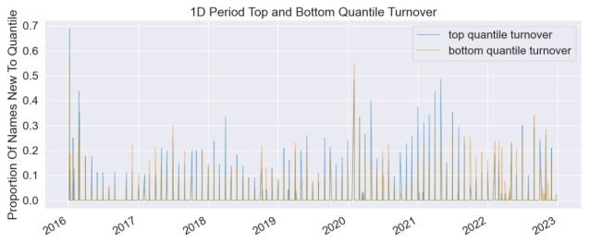

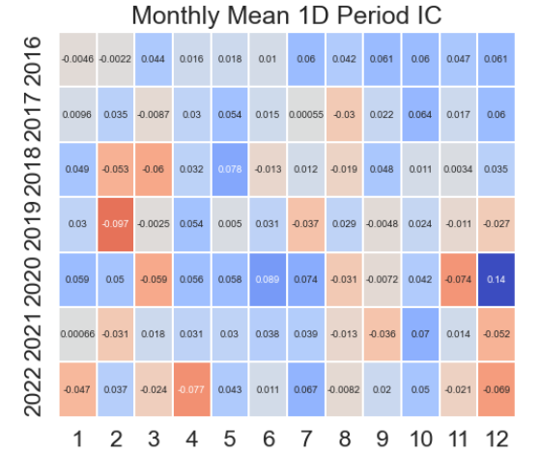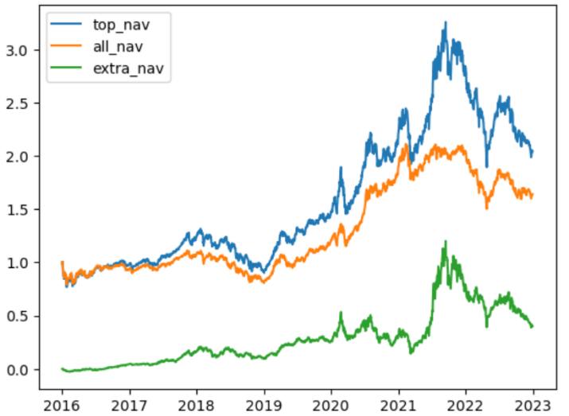

|  |  |
| --- | --- |
| Return/Information Analysis |  |
| Ann.alpha | -0.020 |
| beta | 0.731 |
| Mean Period Wise Return Top Quantile (bps) | 4.738 |
| Mean Period Wise Return Bottom Quantile (bps) | 2.539 |
| Mean Period Wise Spread (bps) | 2.200 |
| IC Mean | 0.015 |
| IC Std. | 0.187 |
| Risk-Adjusted IC | 0.081 |
| t-stat(IC) | 3.347 |
| p-value(IC) | 0.001 |
| IC Skew | -0.185 |
| IC Kurtosis | -0.350 |

# Industry level

## Inspiration——Are industry classifications still valid?

In fund research, it is difficult to be objective and fair when comparing different types of funds, investment varieties, investment fields, investment strategies, industry tracks, etc. Therefore, an important part of fund research is to classify funds, such as by industry, style, theme, etc. Under each category, similar funds are compared and selected to construct the strategy of preferred funds.

There are many ways to classify funds, but for most fund managers, a reasonably ranked fund pool should have a similar investment direction and position distribution to their funds. Therefore, starting from the position details of the fund's semi-annual report and annual report, the exposure of the whole market fund in this category is calculated and ranked with industry classification as the axis, and then the fund with the largest exposure in the category in the market is obtained, and a concept fund pool is constructed.

## Industry fund pool construction

For the distribution of a fund's investment targets, one or more industries in which it is concentrated characterizes the main categories of the fund. Therefore, we mainly focus the classification of the fund on the meso dimension of the industry, and divide it into 31 primary industries based on the Shenwan primary industry classification method. The industry to which the fund belongs is defined as: the proportion of component stocks in the same industry and the largest industry in the fund's total holdings, as the industry's first heavy position of the fund, it is recognized as the industry to which the fund belongs.

Next, the average position to net value ratio of the whole market active equity-biased fund in each subcategory in the past 4 semi-annual reporting periods is calculated and ranked to obtain the fund with the largest proportion of position under this category, and the follow-up fund preferred strategy is constructed in the fund pool of this category.

## Model parameters of the "victory" factor FOF strategy

The sample range and data filter conditions are the same as those of the whole market, and only the frequency of modifying positions is semi-annual, because the frequency of full position disclosure is semi-annually, and the complete industry map can be known.

## Backtesting results: "victory" preferred strategies for industry-level funds

Factors are constructed in the same way as for the whole market, narrowing the scope of the whole market to a certain industry. In the backtest, the top three industries in the number of fund pools are selected, assuming the rolling window t=12, to determine whether the "victory" factor is effective in the industry, and the results of backtesting are as follows. We found that the use of the "victory" factor for fund optimization within the industry is ineffective, indicating that this factor is not suitable for fund optimization at the industry level, and the specific reasons may be related to the sample size of the fund pool and the prosperity of the industry.

### Food and beverage

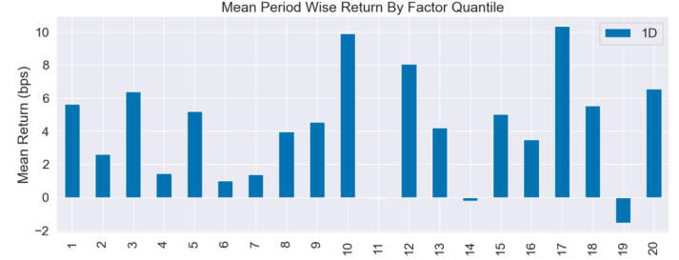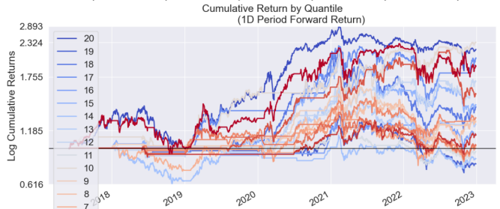

### Electrical equipment

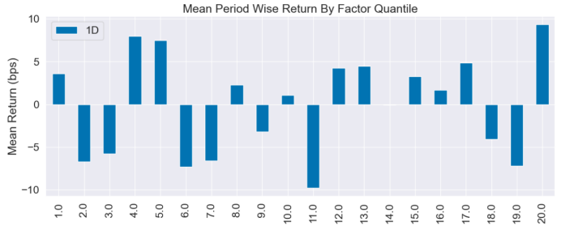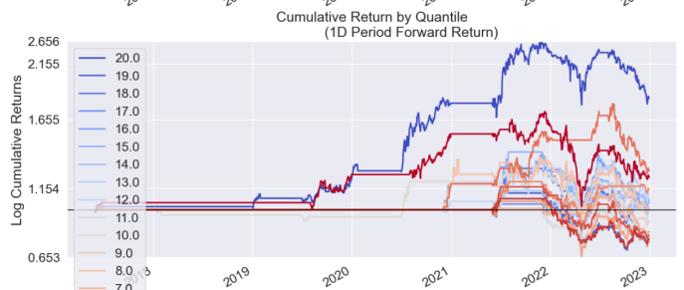

### Pharmaceutical Biotechnology

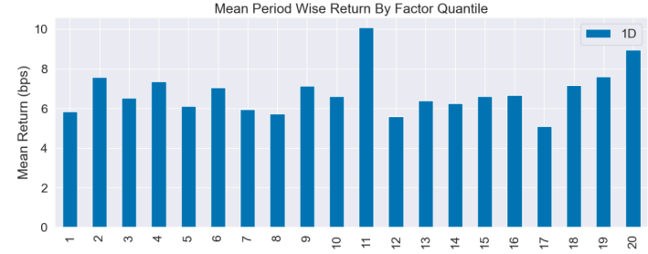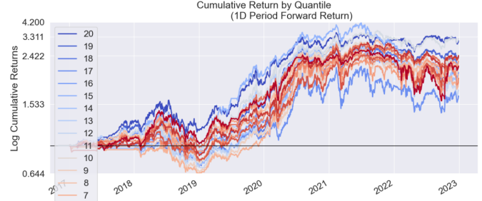

# References

[1]“常胜”优选因子在四层分类下的基金投资策略，张雨蒙，上海证券，2022-04-27